* **How to start VideoPlayer**

Make sure following dependencies:

Python 3.x  
PySide6 library   
moviepy library

Now that you have all the dependency you can run “main.py” on IDE or in CMD. You can use “python main.py” command after opening terminal on same directory where main.py is located on your local machine

* **Reason for repository not having exe and also for app not being dockerized**

1. Github at a time can allow 100mb push to its repo for non LFS files. But video player exe exceeds 100mb
2. Player is not able to run in docker even all the dependency is provided because QT library failing to integrate with docker system plugins. It might be the issue with choosing correct base image to run the python library Pyside6 particularly QTxcb platform. Once the right base image is captured the app will dockerize.
3. see below file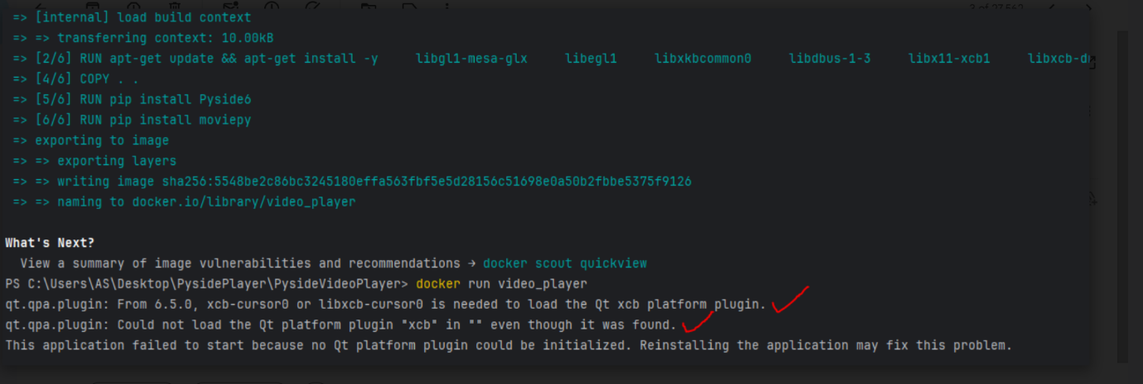

**How to Use Video Player:**

The video player application offers a user-friendly interface with several intuitive features. Here's a breakdown of the various buttons and functionalities:  
  
Play Button: Clicking the "Play" button initiates the playback of the loaded video.  
Pause Button: Pressing the "Pause" button halts the video playback.  
Play Reverse Button: This button enables the reverse playback mode, allowing the user to play the video in the reverse direction.  
Frame Slider: The slider allows users to navigate through different frames of the video. Dragging the slider thumb adjusts the current position in the video.  
Playback Speed Slider: Users can adjust the playback speed using the speed slider. Sliding towards the right increases the speed, while sliding towards the left decreases it.  
Overlay Movement: The application provides the ability to overlay an image on each video frame. Users can click and drag the overlay image to reposition it according to their preference.  
Save Frame Button: Clicking this button saves the current video frame as an image file. Users can specify the filename and destination directory for saving the frame.  
  
**Read COMPREHENSIVE DESIGN DOCUMENTATON FOR VIDEO PLAYER inside package to know working of the video player**